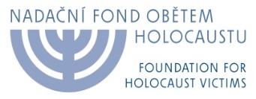
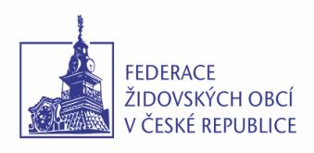
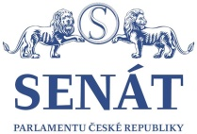

An Annoucement of the Foundation for Holocaust Victims
To Czech News Agency (ČTK) and other Media
Of the Commemorative Event of Holocaust Survivors
held
in the Main Hall of the Czech Senate of the Parliament of the Czech Republic,
on Friday, January 27, 2017

The Federation of Jewish Communities in the Czech Republic in association with the Foundation for Holocaust Victims would like to announce that in association with the Office of the Senate of the Czech Parliament and under the auspices of the President of the Senate, Mr. Milan Štěch, an eleventh year of traditional commemorative event will be held: an Assembly on the Occassion of the Holocaust Remembrance Day and the Day of Prevention of Inhumane Crimes. The event will be held on Friday, January 27, 2017 on the premises of the Main Hall of Waldstein Pallace of the Senate of Czech Parliament at 10.00am.
January 27, 1945 is the day when Auschwitz concentration camp was liberated. This day later became an International Day of the Remembrance of Holocaust Victims.

The commemorative assemblies are attended by tens of survivors of Nazi concentration camps (some of them accompanied by their children), representatives of the organizations associating former prisoners (such as Terezin Initiative, Auschwitz Historical Group, the Hidden Children, an Association of Jewish Soldiers and Resistance Fighters, and a Schwarzheide Historical Group), Chief Rabbi, Prague Archbishop, foreign ambassadors and other important people of cultural and religious life.

This year, the official part of the commemorative event will host the President of the Bavarian Parliament, Ms. Barbara Stamm, along with her delegation. Barbara Stamm will give a short speech on the occasion of her two-day official visit to the Czech Republic.

Speeches by the President of Czech Senate, Mr. Milan Štěch, Vice-Chairperson of the Chamber of Deputies of the Czech Parliament, Mr. Jan Bartošek, the Chairperson of the Federation of Jewish Communities in the Czech Republic, Mr. Petr Papoušek, WWII veteran, Colonel Pavel Vranský, Roma community representative, Radoslav Banga, and the Chairperson of the Board of Directors of the Foudation for Holocaust Victims, Mr. Michal Klíma, and the musical performance by Trio Clavio will constitute the programme of the event.

Petr Papoušek Marta Malá
Chairperson of the Federation of Jewish Director of the Foundation
Communities in the Czech Republic for Holocaust Victims

For Detailed Programme Please See Page 2

Contacts:
PR Dept. Of Czech Senate Eva Davidová, davidovae@senat.cz
Federation of Jewish Communities: MgA. Alena Ortenová, produkce, alena.ortenova@fzo.cz+420 224800858, 604206857

Commemorative Event

on the Occassion of

Holocaust Rememebrance Day and the

Day of Prevention of Inhumane Crimes

January 27, 2017

Czech Senate, Main Hall of the Waldstein Pallace, 10.00am

10,00am
The Address of Milan Štěch,
President of Czech Senate

The Address of Petr Papoušek,
Chairperson
of the Federation of Jewish Communities in Czech Republic

The Address of Jan Bartošek,
Vice-Chairperson of the Chamber of Deputies of Czech Parliament

- Musical Performance

Serban Nichifor: Hebrew Song No.1 "PRAISE JERUSALEM",
Performed by Trio Clavio, Jana Černohouzová – clarinet,
Lucia Fulka Kopsová - violin, Lucie Valčová – piano

The Address of Colonel Pavel Vranský,
WWII veteran, pilot and fighter in the battle of Tobruk

The Address of Radoslav Banga,
Singer and songwriter, the representative of Roma community

- Musical Performance

Serban Nichifor: Hebrew Song No.2 "THE FLOWER IN MY GARDEN"
Trio Clavio

The Address of Michal Klíma,
Chairperson of the Board of Directors of the Foundation for Holocaust Victims

The Address of Barbara Stamm,
President of the Bavarian Parliament

Closing Speech by Petr Papoušek

************************************

11,15 - 12,30pm
- Informal meeting of invited guests on the historical premises of the Czech Senate (space for media)

